Web Programming Lab - Week 3 - Home Assignment

Name: Srihari Srinivasan

Date: 26/01/2025

Section: C Roll No: 40

Registration Number: 220905326



**HTML:**

<!DOCTYPE *html*>

<html *lang*="en">

<head>

<meta *charset*="UTF-8" />

<meta *name*="viewport" *content*="width=device-width, initial-scale=1.0" />

<title>Train Ticket Booking Form</title>

<link

*href*="https://cdn.jsdelivr.net/npm/bootstrap@5.3.0-alpha3/dist/css/bootstrap.min.css"

*rel*="stylesheet"

/>

</head>

<body>

<div *class*="container mt-5">

<div *class*="card shadow-lg">

<div *class*="card-header bg-primary text-white text-center">

<h3>Train Ticket Booking Form</h3>

</div>

<div *class*="card-body">

<form>

*<!-- Passenger Name -->*

<div *class*="mb-3">

<label *for*="passengerName" *class*="form-label"

>Passenger Name</label

>

<input

*type*="text"

*class*="form-control"

*id*="passengerName"

*placeholder*="Enter your full name"

/>

</div>

*<!-- Email Address -->*

<div *class*="mb-3">

<label *for*="email" *class*="form-label"

>Email Address</label

>

<input

*type*="email"

*class*="form-control"

*id*="email"

*placeholder*="Enter your email"

/>

</div>

*<!-- Journey Date -->*

<div *class*="mb-3">

<label *for*="journeyDate" *class*="form-label"

>Journey Date</label

>

<input

*type*="date"

*class*="form-control"

*id*="journeyDate"

/>

</div>

*<!-- Select Train -->*

<div *class*="mb-3">

<label *for*="trainSelect" *class*="form-label"

>Select Train</label

>

<select *class*="form-select" *id*="trainSelect">

<option *selected*>Choose...</option>

<option *value*="1">Express Train</option>

<option *value*="2">Superfast Train</option>

<option *value*="3">Local Train</option>

</select>

</div>

*<!-- Class -->*

<div *class*="mb-3">

<label *class*="form-label">Class</label>

<div *class*="form-check">

<input

*class*="form-check-input"

*type*="radio"

*name*="classOptions"

*id*="firstClass"

*value*="First Class"

/>

<label *class*="form-check-label" *for*="firstClass"

>First Class</label

>

</div>

<div *class*="form-check">

<input

*class*="form-check-input"

*type*="radio"

*name*="classOptions"

*id*="secondClass"

*value*="Second Class"

/>

<label

*class*="form-check-label"

*for*="secondClass"

>Second Class</label

>

</div>

<div *class*="form-check">

<input

*class*="form-check-input"

*type*="radio"

*name*="classOptions"

*id*="thirdClass"

*value*="Third Class"

/>

<label *class*="form-check-label" *for*="thirdClass"

>Third Class</label

>

</div>

</div>

*<!-- Payment Method -->*

<div *class*="mb-3">

<label *for*="paymentMethod" *class*="form-label"

>Payment Method</label

>

<select *class*="form-select" *id*="paymentMethod">

<option *selected*>Choose...</option>

<option *value*="creditCard">Credit Card</option>

<option *value*="debitCard">Debit Card</option>

<option *value*="upi">UPI</option>

<option *value*="netBanking">Net Banking</option>

</select>

</div>

*<!-- Submit Button -->*

<div *class*="d-grid">

<button *type*="submit" *class*="btn btn-primary">

Book Ticket

</button>

</div>

</form>

</div>

</div>

</div>

<script *src*="https://cdn.jsdelivr.net/npm/bootstrap@5.3.0-alpha3/dist/js/bootstrap.bundle.min.js"></script>

</body>

</html>

**Output:**

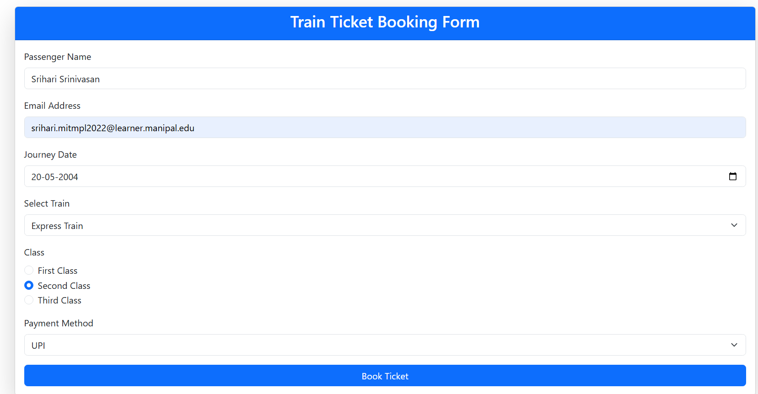



**HTML:**

<!DOCTYPE *html*>

<html *lang*="en">

<head>

<meta *charset*="UTF-8" />

<meta *name*="viewport" *content*="width=device-width, initial-scale=1.0" />

<title>Simple Magazine Cover</title>

<link

*href*="https://cdn.jsdelivr.net/npm/bootstrap@5.3.0-alpha3/dist/css/bootstrap.min.css"

*rel*="stylesheet"

/>

</head>

<body>

<div

*class*="container-fluid text-white text-center bg-dark"

*style*="

height: 100vh;

background-image: url('https://via.placeholder.com/1200x1800');

background-size: cover;

background-position: center;

"

>

*<!-- Magazine Title -->*

<div *class*="pt-5">

<h1 *class*="display-3 fw-bold">MagZone</h1>

<p *class*="lead fw-light">Your Monthly Dose of Inspiration</p>

</div>

*<!-- Featured Highlights -->*

<div *class*="mt-4">

<div *class*="alert alert-primary d-inline-block w-75">

🎙 Exclusive Interview with Top Industry Leaders

</div>

<div *class*="alert alert-danger d-inline-block w-75">

🌍 Explore the Top Travel Destinations of 2025

</div>

<div *class*="alert alert-success d-inline-block w-75">

💡 Discover the Latest Trends in Technology

</div>

</div>

*<!-- Call to Action -->*

<div *class*="mt-5">

<a *href*="#" *class*="btn btn-light btn-lg">Read Now</a>

</div>

</div>

<script *src*="https://cdn.jsdelivr.net/npm/bootstrap@5.3.0-alpha3/dist/js/bootstrap.bundle.min.js"></script>

</body>

</html>

**Output:**

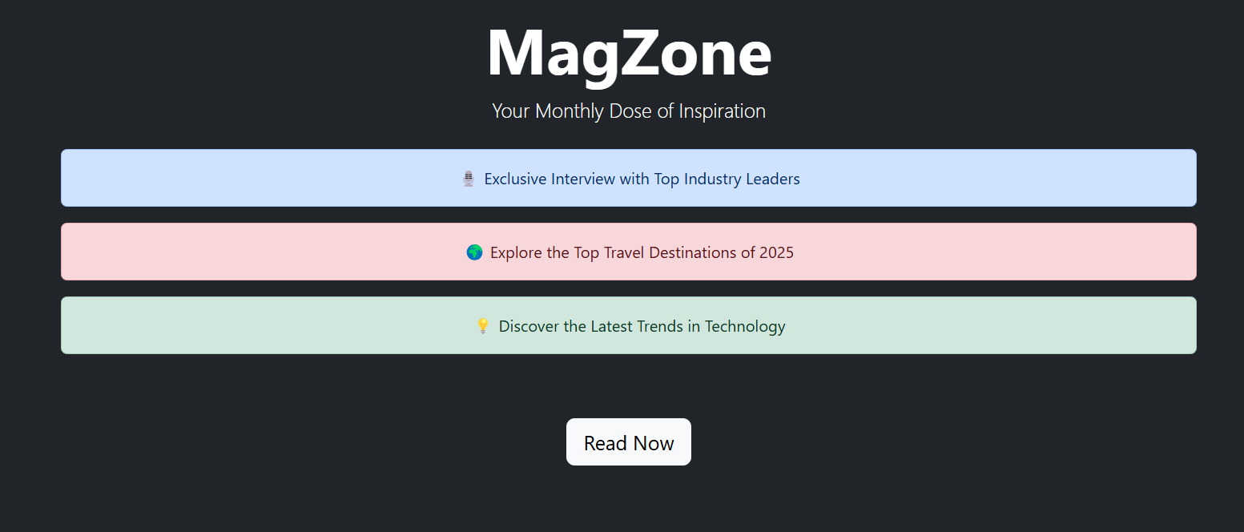



**HTML:**

<!DOCTYPE *html*>

<html *lang*="en">

<head>

<meta *charset*="UTF-8" />

<meta *name*="viewport" *content*="width=device-width, initial-scale=1.0" />

<title>Class Timetable</title>

<link

*href*="https://cdn.jsdelivr.net/npm/bootstrap@5.3.0-alpha3/dist/css/bootstrap.min.css"

*rel*="stylesheet"

/>

</head>

<body>

<div *class*="container mt-5">

<h1 *class*="text-center mb-4">Class Timetable</h1>

*<!-- Carousel -->*

<div

*id*="dayCarousel"

*class*="carousel slide mb-4"

*data-bs-ride*="carousel"

>

<div *class*="carousel-inner">

<div *class*="carousel-item active">

<div

*class*="d-flex justify-content-center align-items-center"

*style*="height: 200px; background-color: #f8f9fa"

>

<h2 *class*="text-dark">Monday</h2>

</div>

</div>

<div *class*="carousel-item">

<div

*class*="d-flex justify-content-center align-items-center"

*style*="height: 200px; background-color: #f8f9fa"

>

<h2 *class*="text-dark">Tuesday</h2>

</div>

</div>

<div *class*="carousel-item">

<div

*class*="d-flex justify-content-center align-items-center"

*style*="height: 200px; background-color: #f8f9fa"

>

<h2 *class*="text-dark">Wednesday</h2>

</div>

</div>

<div *class*="carousel-item">

<div

*class*="d-flex justify-content-center align-items-center"

*style*="height: 200px; background-color: #f8f9fa"

>

<h2 *class*="text-dark">Thursday</h2>

</div>

</div>

<div *class*="carousel-item">

<div

*class*="d-flex justify-content-center align-items-center"

*style*="height: 200px; background-color: #f8f9fa"

>

<h2 *class*="text-dark">Friday</h2>

</div>

</div>

<div *class*="carousel-item">

<div

*class*="d-flex justify-content-center align-items-center"

*style*="height: 200px; background-color: #f8f9fa"

>

<h2 *class*="text-dark">Saturday</h2>

</div>

</div>

</div>

<button

*class*="carousel-control-prev"

*type*="button"

*data-bs-target*="#dayCarousel"

*data-bs-slide*="prev"

>

<span

*class*="carousel-control-prev-icon"

*aria-hidden*="true"

></span>

<span *class*="visually-hidden">Previous</span>

</button>

<button

*class*="carousel-control-next"

*type*="button"

*data-bs-target*="#dayCarousel"

*data-bs-slide*="next"

>

<span

*class*="carousel-control-next-icon"

*aria-hidden*="true"

></span>

<span *class*="visually-hidden">Next</span>

</button>

</div>

*<!-- Timetable Table -->*

<table *class*="table table-bordered text-center">

<thead *class*="table-dark">

<tr>

<th>Time</th>

<th>Monday</th>

<th>Tuesday</th>

<th>Wednesday</th>

<th>Thursday</th>

<th>Friday</th>

<th>Saturday</th>

</tr>

</thead>

<tbody>

<tr>

<td>08:00 - 09:00</td>

<td>WP</td>

<td>WP LAB (C2)</td>

<td>EEFM</td>

<td>WP LAB (C1)</td>

<td>PCAP</td>

<td>CD LAB (C1)</td>

</tr>

<tr>

<td>09:00 - 10:00</td>

<td>PE-II</td>

<td>WP LAB (C2)</td>

<td>PE-II</td>

<td>WP LAB (C1)</td>

<td>OE</td>

<td>CD</td>

</tr>

<tr>

<td>10:00 - 10:30</td>

<td>Break</td>

<td>Break</td>

<td>Break</td>

<td>Break</td>

<td>Break</td>

<td>Break</td>

</tr>

<tr>

<td>10:30 - 11:30</td>

<td>EEFM</td>

<td>Lunch Break</td>

<td>CD</td>

<td>Lunch Break</td>

<td>PE-I</td>

<td>Lunch Break</td>

</tr>

<tr>

<td>11:30 - 12:30</td>

<td>PE-II</td>

<td>Lunch Break</td>

<td>OE</td>

<td>Lunch Break</td>

<td>PCAP</td>

<td>PE-II</td>

</tr>

<tr>

<td>12:30 - 01:00</td>

<td>Lunch Break</td>

<td>Lunch Break</td>

<td>Lunch Break</td>

<td>Lunch Break</td>

<td>Lunch Break</td>

<td>Lunch Break</td>

</tr>

<tr>

<td>01:00 - 02:00</td>

<td>PCAP LAB (C1)</td>

<td>EEFM</td>

<td>OE</td>

<td>PCAP</td>

<td>PCAP LAB (C2)</td>

<td>CD</td>

</tr>

<tr>

<td>02:00 - 03:00</td>

<td>PLACEMENT</td>

<td>PLACEMENT</td>

<td>PLACEMENT</td>

<td>PLACEMENT</td>

<td>PLACEMENT</td>

<td>PLACEMENT</td>

</tr>

</tbody>

</table>

</div>

<script *src*="https://cdn.jsdelivr.net/npm/bootstrap@5.3.0-alpha3/dist/js/bootstrap.bundle.min.js"></script>

</body>

</html>

**Output:**

